

**BI Solution Concept**

**Mercedes-Benz Dealers**

|  |  |
| --- | --- |
| Requested By | Kyril Bucha |
| Business Owner | Kanstantsin Arzhakhouski |
| Contact Info. | Kanstantsin_Arzhakhouski@epam.com |

**CONTENTS**

Logical Diagram ……………………………………………………………………………………………………….………………2

Physical diagram………………………………………………………………………………………………………………………3

Dimension ……………………………………………………………………………………………………………………………… 4

Dimension Types …………………………………………………………………………………………………………. 4

Dimension Hierarchies………………………………………………………………………………………………….. 5

Facts ………………………………………………………………………………………………………………………………………. 6

Facts Aggregations …………………………………………………………………………………………………………6

Dataflow Diagram ………………………………………………………………………………………………………………….. 7

Partitioning rules ……………………………………………………………………………………………………………………. 8

Strategy of Parallel execution …………………………………………………………………………….………………….. 9

**LOGICAL DIAGRAM**

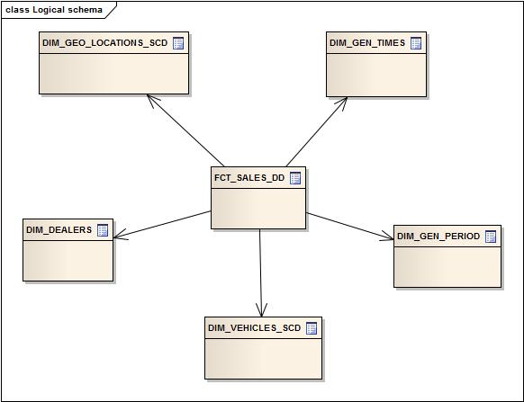

**PHYSICAL DIAGRAM**

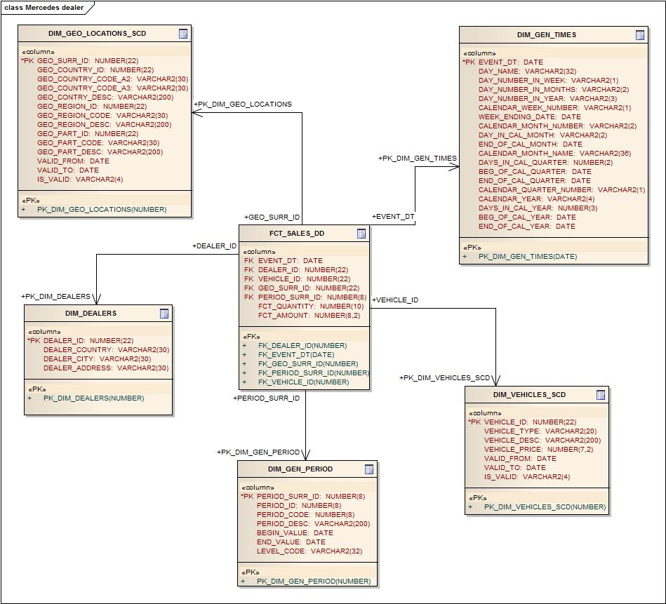

**DIMENSIONS**

**DIMENSION TYPES**

|  |  |  |  |  |
| --- | --- | --- | --- | --- |
| NAME | TYPE | SIZE | MERGED DIMENSIONS | DESCRIPTION |
| DIM_GEN_TIMES | SCD1 | BIG | dw.t_days  dw.lc_days  dw.t_weeks  dw.t_months  dw.lc_months  dw.t_quarters  dw.t_years  dw.t_localizations | Dimension consists of a calendar value list |
| DIM_GEO_LOCATIONS_SCD | SCD2 | SMALL | dw.t_countries  dw.lc_countries  dw.t_cntr_groups  dw.lc_cntr_groups  dw.t_geo_regions  dw.lc_geo_regions  dw.t_geo_objects  dw.t_geo_types  dw.t_geo_object_links  dw.t_localizations  dw.t_geo_action | Dimension with locatons information and hierarchy of countries, groups of countries and regions. |
| DIM_GEN_PERIODS | SCD1 | SMALL | dw.gen_periods  dw.lc_gen_periods | Dimension with information about business periods of dealer’s activity |
| DIM_VEHICLE_SCD | SCD2 | BIG | dw.t_vehicle_type  dw.t_vehicle_desc  dw.lc_vehicle_type  dw.t_vehicle_price  dw.t_localizations | Dimension with information about vehicles, and types. It includes the history of changing of price |
| DIM_DEALERS | SCD1 | SMALL | dw.t_dealers  lc.t_dealers | Contain information about dealers |

**DIMENSIONS HIERARCHIES**

DIM _TIMES:

Hierarchy DAY-MONTH-QUARTER-YEAR

|  |  |  |  |
| --- | --- | --- | --- |
| Name | LEVEL_CODE | LEVEL_DESC | LEVEL_NATURAL_KEY |
| DAYs | DAY | Store all day at the calendar | DAY_ID |
| MONTHs | MONTH | Store all months at the calendar year | MONTH_ID |
| QUARTERs | QUARTER | Store all quarters at the calendar  year | QUARTER_ID |
| YEARs | YEAR | Store all years | YEAR_ID |

DIM_VEHICLE_SCD:

Hierarchy CAR-TYPE

|  |  |  |  |
| --- | --- | --- | --- |
| Name | LEVEL_CODE | LEVEL_DESC | LEVEL_NATURAL_KEY |
| CARs | CAR | Store vehicle number | VEHICLE_ID |
| TYPEs | TYPE | Store description of types of vehicle | VEHICLE_TYPE |

**FACTS**

**FACTS AGGREGATIONS**

One-day granularity. This level consist of two aggregations (by number, by amount sold)

|  |  |
| --- | --- |
| Table Name | Aggregation Level |
| FCT_SALES_DD | Number of sold vehicles and amount sales. Every day calculation. |

**DATAFLOW DIAGRAM**

 Source files

**Star cleansing area**

**Data Mart**

**Star area**

DW area

DW Cleansing area

ETL procedure

3NF

Stage area

Cleansing area

**PARTITIONING RULES**

Main rule is separate stored data in different tablespace.

CREATE TABLE FCT_INCOME_PRODUCT_DAYLY

(

event_dt DATE NOT NULL,

...

)

PARTITION BY RANGE(event_dt)

(

PARTITION 2000

VALUES LESS THAN (to_date('12/31/2000', 'mm/dd/yyyy')) tablespace SALES_2000,

PARTITION 2005

VALUES LESS THAN (to_date('12/31/2005', 'mm/dd/yyyy')) tablespace SALES_2005,

PARTITION 2010

VALUES LESS THAN (to_date('12/31/2010', 'mm/dd/yyyy')) tablespace SALES_2010,

PARTITION 2011

VALUES LESS THAN (to_date('12/31/2011', 'mm/dd/yyyy')) tablespace SALES_2011,

PARTITION 2012

VALUES LESS THAN (to_date('12/31/2012', 'mm/dd/yyyy')) tablespace SALES_2012,

PARTITION 2013

VALUES LESS THAN (to_date('12/31/2013', 'mm/dd/yyyy')) tablespace SALES_2013,

PARTITION INC_OTHERS

VALUES LESS THAN (MAXVALUE) tablespace SALES_OTHER

);

**STRATEGY OF PARALLEL EXECUTION**

For increase performance, use all types of parallel execution. Such as parallel query, parallel DML, parallel DML. Pay special attention to the use of parallel query. Parallel query allows a single SQL SELECT statement to be divided into many smaller queries, with each component query being run concurrently, and then the results from each combined to provide the final answer with highly performance.